AWS Lambda

What is AWS Lambda
- AWS lambda is a serverless computing.
- it is computing service which we can use to run our code without provisioning and managing the servers.
- with aws lambda, you can run your code for virtually any type of application or backed service all with zero administration.
- With AWS Lambda, you only pay for the compute time that you consume, which makes it a cost-effective solution for building scalable applications.
- Additionally, AWS Lambda supports a variety of programming languages, making it easy for developers to write their code in the language they are most comfortable with.
- AWS lambda runs our code on a high availability compute infrastructure.
- AWS lambda executes our code when needed and scales automatically from a few requests per day to thousands per request.
- we can pay only when our code run. No charges can apply when the code is not running.
- all you need to do only supply your code to lambda in the form of one or more lambda function.
- lambda supports the languages like node JS, python, go, ruby, c#, java, PowerShell, provided Runtime API (custom runtime).
- AWS Lambda is often used to build serverless applications, which are applications that run in the cloud without requiring the developer to manage the underlying infrastructure.

IMPORTANT POINTS
- AWS Lambda runs a function for a maximum of 15 minutes (900 seconds) per execution.
- If a Lambda function exceeds 15 minutes, AWS automatically terminates it.
- Therefore, AWS Lambda is suitable only for short-running, event-driven tasks.
- For long-running processes, services like EC2 or containers should be used instead.

KEY POINTS
- Serverless computing
- Run code on demand
- Event driven
- Automatic scaling
- Cost effective
- High availability
- Support limited languages
- Function based execution
How Lambda Works
- first, you upload your code to lambda in one or more function.
- then lambda executes the code
- after the code is envoked, lambda automatically take care of provisioning and managing required servers.

Differences in AWS lambda and EC2
AWS Lambda
- It is a platform as a service
- It only supports the limited languages like java, python, ruby, PowerShell, c#, node JS, go, runtime API
- In AWS lambda we can only for the time when the code runs
EC2
- It is a infrastructure as a service
- it has no environment so we can run the code on any languages
- In EC2 we can pay per minute as well as pay per hour

Terms In Aws Lambda
Function:
- a function is a resource that you can invoke to run your code in AWS lambda.
- A function has code that processes events and a runtime that passes request and responses between lambda and the function code.
Runtime:
- lambda runtimes allows functions in different languages to run in the same base execution environment.
- The runtime sits in between the lambda service and your function code relying invocation events, context information and responses between the two.
Event:
it is a JSON formatted text document that contains data for a function to process.
Event Source/ Trigger:
An AWS service such as Amazon SNS or a custom service that triggers your function and executes its logic.
Downstream Resource:
An AWS service, such as Dynamo DB tables or S3 buckets that your lambda function call once it is triggered.
Concurrency:
Number of requests that your function is serving in any given time.

Different way to invoke Lambda Function
- Synchronous invoke (push)
- Asynchronous invoke (event)
- Poll-based invoke (pull based)
1. Synchronous Invoke:
- Synchronous invoke are the most straight forward way to invoke your lambda function. In this model your functions execute immediately when you perform the lambda invoke API call.
- Invocation flag specifies a value of “request-response”.
- You wait for the function to process the event and return a response.
Here is a list of services that invoke lambda function synchronously:
- Elastic Load Balancer
- Amazon Cognito
- Cloud front
- API Gateway
- Amazon Lex
- Kinesis data firehose

2. Asynchronous Invoke:
- For asynchronous invocation, lambda places the event in a queue and returns a success response without additional information.
- Lambda queues the event for processing and returns a response immediately.
- You can configure lambda to send an invocation record to another service like SQS, SNS, lambda and event bridge.
Here is a list of services that invoke lambda function asynchronously:
- Amazon S3
- Amazon SNS
- SES
- Cloud watch logs
- Cloud watch events
- AWS code commit
- AWS config

3. Poll-Based Invoke:
The invocation model is designed to allow you to integrate with AWS stream and queue-based service with no code or server management lambda will poll the following service on your behalf, retrieve records and invoke your function.
The following are supported service:
- Amazon Kinesis
- Amazon SQS
- Amazon Dynamo DB Streams

S3 TRIGGER WITH LAMBDA
1.Create A Role For Lambda
1.type-----------> aws service
2.use case------> lambda
3.policy----------> Administrator access
4.role name-----> role-for-lambda
2.Create A S3 Bucket
1.my-s3-bucket (bucket is private)

3.Go To Dynamodb
1.create a table
- table-name---> newtable
- partion key---> unique
- create
4.Create A Lambda Function
- author from scratch
- name---------> lambda
- runtime------> python3.10
- advanced setting---role---existing role---(role-for-lambda)
5.Deploy Code On Lambda
1.paste the code on function
import boto3
from uuid import uuid4
dynamodb = boto3.resource('dynamodb')
table = dynamodb.Table('newtable')
def lambda_handler(event, context):
for record in event['Records']:
bucket_name = record['s3']['bucket']['name']
object_key = record['s3']['object']['key']
size = record['s3']['object'].get('size', 0)
event_name = record['eventName']
event_time = record['eventTime']
table.put_item(
Item={
'unique': str(uuid4()),
'Bucket': bucket_name,
'Object': object_key,
'Size': size,
'Event': event_name,
'EventTime': event_time
}
)
return {
'statusCode': 200,
'body': 'Success'
}
2.and deploy the code
5.Then Trigger the S3 Bucket
- click on trigger
- search---> s3
- bucket---> my-s3-bucket
- event----all-object-create-event
- create a trigger

7.Add Objects In S3 Bucket
- click on s3 bucket
- add objects in the buckets
8.Go To DynamoDB
- click on tables
- click on newtable
- click on explore item

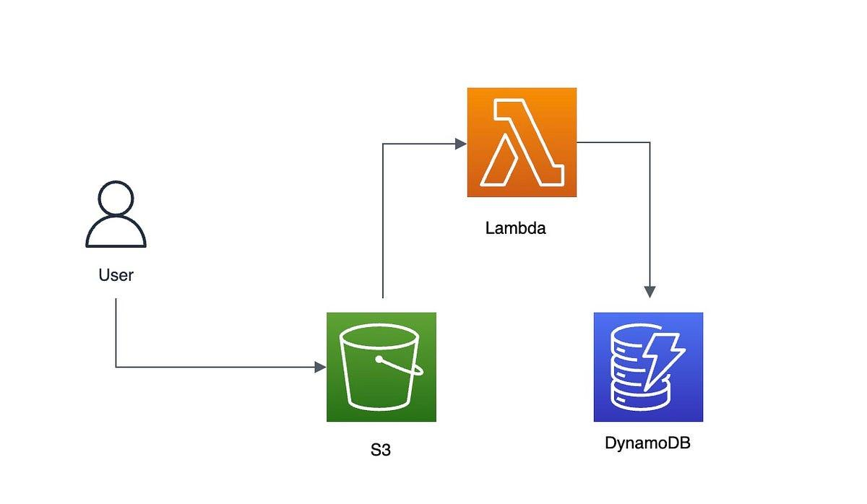

CREATING SNAPSHOTS WITH PYTHON SCRIPT

1.create a instance in Mumbai region and in Singapore region
2.Create A Role
- role-------------aws service
- use case-------lambda
- policy----------Administrator Access
- role-name----role-for-lambda

3.Create A Lambda Function In Lambda
1.author from scratch
2.function name-----> ebs-snapshot-function
3.runtime--------------> python3.10
4.role----> select existing role-----> role-for-lambda
5.create a function

4.On The Lambda Function
1.paste the code

import boto3

def lambda_handler(event, context):
regions = ['ap-south-1', 'ap-southeast-1'] # Mumbai + Singapore

for reg in regions:
print(f"Checking region {reg}")

ec2 = boto3.client('ec2', region_name=reg)

volumes = ec2.describe_volumes(
Filters=[{'Name': 'status', 'Values': ['in-use']}]
)

for volume in volumes['Volumes']:
volume_id = volume['VolumeId']
az = volume['AvailabilityZone']

print(f"Creating snapshot for {volume_id} in {az}")

snapshot = ec2.create_snapshot(
VolumeId=volume_id,
Description='Lambda automated snapshot'
)

snapshot_id = snapshot['SnapshotId']

# Tag snapshot
ec2.create_tags(
Resources=[snapshot_id],
Tags=[
{'Key': 'CreatedBy', 'Value': 'Lambda'},
{'Key': 'VolumeId', 'Value': volume_id}
]
)

return {
'statusCode': 200,
'body': 'Snapshots created successfully'
}

2.Deploying the code
3.Go To Configuration And Edit
1.memory----- 512MB
2. Timeout ---- 3–5 minutes
3.save

4.Test Lambda
- create a new test event
{
"key": "test"
}
- test again

5.Verify Snapshots
1. Go to Mumbai region & Singapore region
2. EC2 → Snapshots
3. You should see snapshot created

EVENTBRIDGE TRIGGER WITH LAMBDA

1. CREATE IAM ROLE FOR LAMBDA
- role ----> role-for-lambda-eventbridge

2.CREATE LAMBDA FUNCTION
- Create a Function
- Author from Scratch
- Function Name → ec2-state-monitor
- Runtime → Python 3.10
- Existing Role (role-for-lambda-eventbridge)
- Create Function

3. DEPLOY PYTHON CODE
import json

def lambda_handler(event, context):

instance_id = event['detail']['instance-id']
state = event['detail']['state']

print(f"EC2 Instance {instance_id} changed state to {state}")

return {
'statusCode': 200,
'body': json.dumps('EC2 state captured successfully')
}

4. ADD EVENTBRIDGE TRIGGER
- click on trigger
- Trigger configuration --------> EventBridge (CloudWatch Events)
- rule ------> Create a new rule
- rule_name ----> ec2-state-rule
- Rule type ------> Event pattern
- EC2
- All Events
- add trigger

5. CREATE EC2 INSTANCE

6. TEST THE PRACTICAL
- Stop Instance
- Start Instance
- Reboot Instance

7. VERIFY CLOUDWATCH LOGS
- Click on Lambda → ec2-state-monitor
- Click on Monitor Tab
- Click on View CloudWatch Logs
- Open Latest Log Stream

8. OUTPUT YOU RECEIVED
- EC2 Instance i-088522fbea2f6ab23 changed state to pending
- EC2 Instance i-088522fbea2f6ab23 changed state to running
- EC2 Instance i-088522fbea2f6ab23 changed state to stopping

